

## Abstract:

The Capital Asset Pricing Model (CAPM) is a financial framework that assesses the expected return on an investment based on its systematic risk, represented by beta. CAPM establishes a linear relationship between an asset's expected return, the risk-free rate, and the market risk premium. By incorporating risk and return components, it aids investors in making informed decisions about the potential profitability of an investment relative to its inherent risk.

## What is CAPM?

The CAPM (Capital Asset Pricing Model) is a financial model used to determine the expected return on an investment given its risk compared to the overall market. It is widely used in finance for estimating the appropriate required rate of return for an investment.

## History of CAPM:

The Capital Asset Pricing Model (CAPM) was introduced by William Sharpe (1964) and John Lintner (1965). It is built on the earlier work of Harry Markowitz (1959)Who developed the model of portfolio choice.

**Assumptions of**



The Capital Asset Pricing Model (CAPM) relies on several key assumptions, which are fundamental to its application and interpretation in financial theory. These assumptions include:

1. **Perfect Market Conditions:** CAPM assumes that markets are efficient, meaning all available information is reflected in asset prices, and there are no transaction costs or taxes. Investors have access to the same information and can trade assets freely.
2. **Homogeneous Expectations**: Investors in the market have homogeneous expectations,

meaning they all use the same inputs and parameters to assess the risk and return of assets. This assumption allows for the use of a single market portfolio to represent all investors' portfolios.

1. **Rational Investors:** CAPM assumes that investors are rational and risk-averse. Rational

investors seek to maximize their expected returns while minimizing risk. They make decisions based on the expected return and risk of assets and portfolios.

1. **Single Time Horizon**: The model assumes a single time horizon for all investors, implying that all investors have the same investment horizon. This assumption simplifies the analysis but may not reflect the diverse investment horizons of real investors.
2. **Risk-Free Rate:** There exists a risk-free asset with a constant return that is known with

certainty. Typically, this is represented by the yield on short-term government bonds, such as

U.S. Treasury bills. This assumption provides a baseline return for investors to compare against the expected returns of risky assets.

1. **Well-Diversified Portfolios:** Investors can achieve full diversification by holding a well- diversified portfolio of assets. In other words, investors can eliminate unsystematic or

idiosyncratic risk through diversification, leaving only systematic risk relevant for pricing assets.

1. **Linear Relationship:** CAPM assumes a linear relationship between the expected return of an asset and its beta (systematic risk). This assumption implies that investors are compensated for taking on systematic risk but not for unsystematic risk.

While these assumptions simplify the model and its application, they may not always hold true in real- world financial markets. Despite these limitations, CAPM remains a widely used tool for estimating the expected returns of assets and evaluating investment opportunities.

# Formula to calculate CAPM:

The CAPM formula is as follows:

|  |  |  |
| --- | --- | --- |
|  | ***E*(*Ri*)=*Rf*+*βi*×(*E*(*Rm*)−*Rf*)** |  |

Where:

|  |  |  |  |
| --- | --- | --- | --- |
| •  •  • | *E*(*Ri*) | | is the expected return on the investment. |
| *Rf* | is the risk-free rate of return (typically the yield on government bonds).  is the beta of the investment, representing its volatility or systematic risk compared to | |
| *βi* |
| the overall market.   * *E*(*Rm*) is the expected return on the market portfolio (usually represented by a market index such as the S&P 500). | | | |

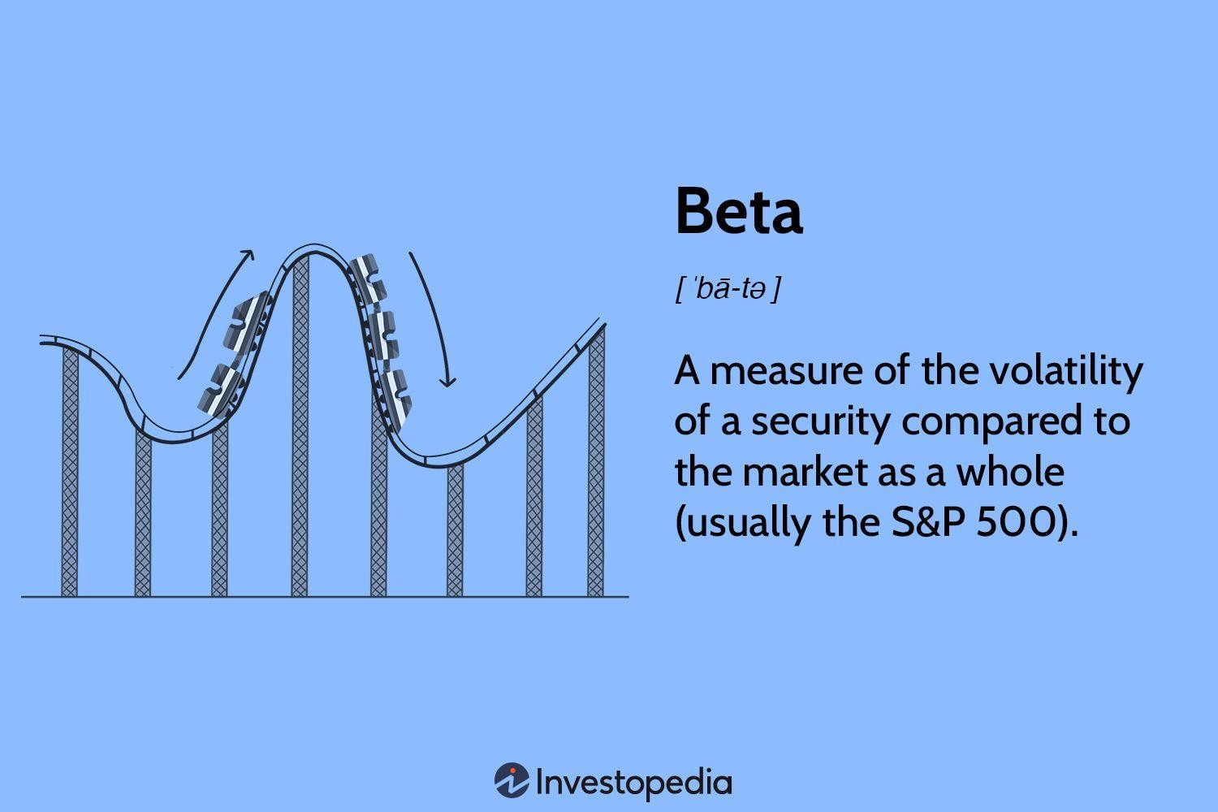

## How to calculate Beta?

### Beta = Covariance/ Variance

Where:

Covariance = Measure of stocks return relative to that of the market Variance=Measure of how the market moves relative to its mean

## Why is CAPM important?

The Capital Asset Pricing Model (CAPM) is important for several reasons in the field of finance:

1. **Estimation of Expected Returns:** CAPM provides a framework for estimating the expected returns of assets based on their systematic risk, as measured by beta. This is crucial for investors and financial analysts in making investment decisions and assessing the potential returns of various assets.
2. **Cost of Capital:** CAPM helps in determining the cost of equity, which is essential for calculating

the weighted average cost of capital (WACC) for a company. This is valuable for businesses when

evaluating potential projects or investments, as they need to compare the expected returns of projects against their cost of capital.

1. **Portfolio Management**: CAPM aids portfolio managers in constructing and optimizing

portfolios. By using CAPM, portfolio managers can determine the appropriate mix of assets that maximizes expected returns for a given level of risk or minimizes risk for a desired level of return.

1. **Risk Management**: CAPM assists in understanding and managing systematic risk, which is the risk that cannot be diversified away. Investors can use CAPM to identify assets that are

undervalued or overvalued relative to their expected returns given their level of systematic risk.

1. **Benchmarking:** CAPM provides a benchmark against which the performance of investments and portfolios can be evaluated. By comparing actual returns to the expected returns predicted by CAPM, investors can assess the performance of their investments and determine whether

they are adequately compensated for the level of risk taken.

1. **Academic Research:** CAPM has been widely studied and serves as a foundational model in financial economics. It has contributed to the development of modern portfolio theory and asset pricing models, leading to further advancements in financial research and practice.
2. **Regulatory Purposes:** In some cases, CAPM or similar models are used for regulatory

purposes, such as setting required rates of return for regulated utilities or assessing the riskiness of financial institutions' assets.

Overall, CAPM is important because it provides a framework for understanding the relationship between risk and return in financial markets, which is fundamental to investment decision-making, portfolio management, and financial analysis.

# Problem:

### Calculating Beta for Apple

An investor is looking to calculate the beta of Apple (AAPL) as compared to the SPDR S&P 500 ETF Trust (SPY). Based on recent five-year data. Let's calculate Beta using Excel.



**Calculating CAPM for 3 Stocks**

An investor is looking to calculate the expected return of 3 different stocks. The risk free return is 3% and the expected market rate of return is 9%. What is the expected rate of return of the following 3 stocks

|  |  |
| --- | --- |
| Amount Invested | β |
| $ 350,000.00 | 1 |
| $ 250,000.00 | 0.2 |
| $ 400,000.00 | 2.5 |

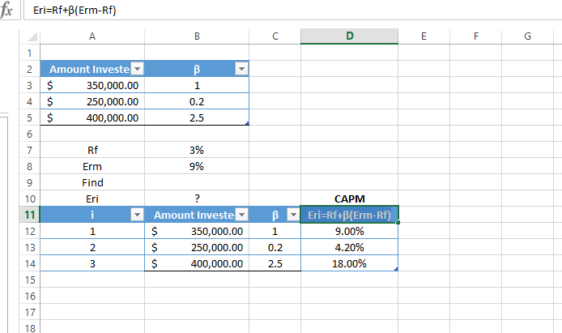

# Conclusion:

In conclusion, the Capital Asset Pricing Model (CAPM) stands as a fundamental pillar in the realm of financial theory and practice, offering valuable insights into the relationship between risk and return

in investment decision-making. Through its foundational principles and assumptions, CAPM provides a systematic framework for estimating expected returns, determining the cost of capital, optimizing

portfolios, managing risk, and benchmarking investment performance. Despite its simplifying assumptions and limitations, CAPM remains a widely utilized tool in finance, serving as a cornerstone for academic research, portfolio management, risk assessment, regulatory purposes, and guiding investors

in navigating the complexities of financial markets. As a seminal model, CAPM continues to influence both theory and practice, shaping the landscape of modern finance and contributing to ongoing advancements in the field.